EDL – EE 344 Project Proposal 2016-17

Multi-Temperature Diode Characterizer

Group Number 16

OV Shashank 14D070021

Yogesh Mahajan 14D070022

Ayush Agrawal 14D070042

# ABSTRACT

The system extracts the DC Current vs Voltage and the small-signal AC characteristics of two terminal devices, specifically of diodes, but can be used for analysis of devices whose DC characteristics are required. It contains a temperature settable platform and hence can characterize the device at various temperatures as supplied by the user, which can be used to study the dependence of temperature on the device performance. The system comes along with Graphical User Interface was easy configuration and utilization.

# Project description

## Background and Motivation

Though in the research field, systems exist that provide temperature settable platforms, there is not an easy way to quickly characterize a devices’ characteristic at various temperatures using the temperature settable platform systems. Usually characterization requires a user to snap the device to the platform and manually apply all the voltages and currents and at various frequencies which wastes a lot of the time which can be utilized in other productive tasks.

Some of the already implemented thermoelectric cooler systems in the industry and universities are:

* <http://www.ti.com/lit/an/spra873/spra873.pdf> by Texas Instruments
* <http://www.ti.com/lit/an/slua202a/slua202a.pdf> by Texas Instruments
* <http://www.asee.org/public/conferences/1/papers/1842/download>

The last reference corresponds to a paper published in a conference where a team developed a low-cost device to characterize the IV characteristics of a Solar Cell. We are going a step beyond by doing the same at various temperatures and with better accuracy.

Some other issues which creation of this device is the cost of the Peltier Cooler and the support system it requires to operate at reasonable efficiency.

Project Goal

Elaborating further on the abstract the goal is to create a complete system which takes user inputs and performs the IV Characterisation on the device as placed by the user at the set temperatures and providing the Output data to the user back through the interface on a Computer.

Our proposed system performs the following tasks:

* User I/O using a Graphical User Interface on a Computer
* Temperature control of a metallic platform
* DC IV Characteristics of two terminal devices specifically diodes at multiple temperatures
* Small Signal Parameter Extraction for Diodes

Our system is unique in its integration of two different systems, by harnessing the utility of one system, i.e. the temperature control system, in the field of device characterisation dependent on temperature which will be helpful in further evolving the utility of devices which may exhibit certain desirable characteristics, E.g. Analysing the most efficient temperature for operation of a solar cell or operating temperature ranges for devices.

## Specifications

### Customer Specifications

* Voltage Range: $±10V$ (with variable precision)
* Current Range: $±100mA$ (with variable precision)
* Temperature Range: $-{10}^{0}C to {80}^{0}C$ with precision of $1^{0}$

In principle, any two-terminal device can be characterized in DC, by the system. The hardware will provide for a clamping mechanism which is the user must use to secure the device under test, onto the temperature settable platform.

Supported 2-Terminal Devices are

* Diodes
* LEDs
* Zener Diodes
* Solar Cells
* Resistors

The User will also be provided with a Graphical Interface which will be supported on both Windows and Linux Systems. It will be used by the user to provide the different temperature values and control on a high level, the operation of the system.

Supply to the system by be provided using the AC Mains along with an adapter.

### Technical Specifications

Apart from the already mentioned customer specifications, to achieve the customer specification with good accuracy, the actual supported range would for which the system is designed for is wider

* Voltage Range: $±15V$
* Current Range: $±300mA$
* Temperature Range: $-{15}^{0} to {85}^{0}$

Because our system targets a technical audience which care about the technical aspects of devices, the customer specifications cover almost all of the specifications.

# Technical Design

## Possible Solutions and Design Alternatives

For finding the temperature dependent I-V characteristics of a device, alternative things that can be used is a **Coil Heater**. But it has many cons when it is compared against a Peltier Cooler. The following are some of the cons

* Coil Heater cannot be taken below room temperature.
* Energy Conversion ratio is quite poor. Part of the energy is lost in form of light energy.
* Controlling the temperature through coil heater is not as fast as for the Peltier cooler.
* Rise time is more for coil heater.

Typically, a coil heater is not cheap.

## System-level overview

The system consists of five major subsystems. These can be visualised in the form of the following minimalistic block diagram:

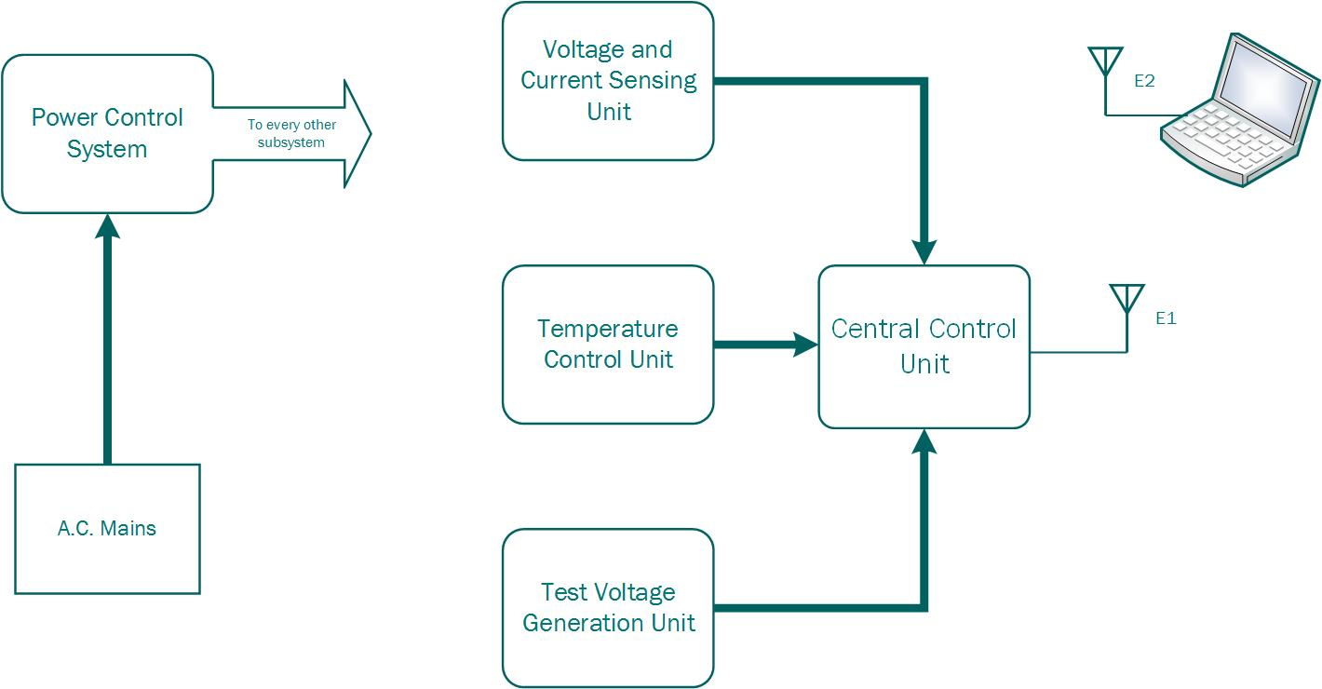

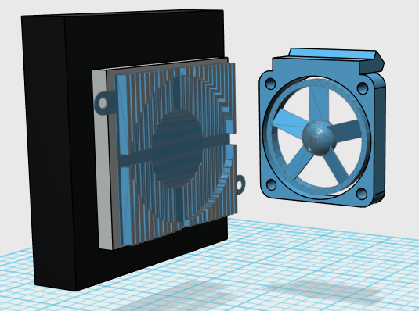

### Temperature Control Unit

It contains the following components

* Peltier Cooler Setup: It consists of the Peltier cooler, heat sink, metal plate and a 12V fan. The connection can be understood from the adjacent figure.
* Black Cuboid: Metal Plate
* Silver Cuboid: Peltier Cooler
* Blue Mesh: Heat Sink

### Temperature Sensor

This considers the temperature sensor mounting along with the voltage regulation and control circuitry.

### Micro-Controller (Slave)

This microcontroller works as a slave to the central control unit and carries out the task of controlling the temperature on the metal plate using PID algorithm.

### Power Supplying System

This subsystem takes care of all the voltage and current requirements of the whole system. It consists of voltage regulators and protection circuitry for supplying correct and stable voltage levels and protection against the overshooting of voltage, current and temperature levels.

### Voltage and Current Sensing Unit

As the name suggests, this subsystem takes care of the voltage and current measurement across and through the DUT respectively. The process involves making the system compatible for measuring high voltages (around 2-5V) and low voltages (of order mV) and for variable range of currents. The various components used in this subsystem would be

* Various kinds of OP-Amps: Per the application
* Analog Switches (Multiplexors)
* PGA: For measuring a range of voltages
* Digital Potentiometers

### Test Voltage Generation Unit

It is used for creating the voltage sweep for measuring the DC I-V characteristics of the device and for creating oscillating voltages for measuring the small signal parameters of the DUT. It will have the following components

* DC Voltage Controller: DAC + PGA + Attenuators
* Variable Frequency Programmable oscillator

### Central Control Unit

It consists of the main micro-controller which facilitates the overall working of the system. Its functions involve adjusting the temperature (using the slave micro-controller), implement safety measures, measure and communicate the I-V characteristics to the user. This subsystem also contains the communication circuitry for communication with the mobile device (Laptop) and between the different subsystems.

### Software

Consists of a simple GUI for plotting the I-V characteristics at different set temperatures.

Performance Validation

We wish to test and plot the temperature I-V characteristic plots for the following devices:

* Resistors
* Normal Diode
* Zener Diode
* Solar Cell

For the final design demo, we would like to demonstrate the I-V plot for the above said devices at various temperatures (ranging between -10°C to 80°C). We will also find the small signal parameter of the diode, i.e. dynamic resistance for varying ranges of base voltage.

This whole process is done while the device under test is placed inside the enclosing made for the whole system.

# Project plan

The primary tasks in the project can be seen from the following Gantt Chart (units in days):



Every task which requires a component starts out with testing of the components. Any component that is not readily replaceable will be tested at an earlier time. The above tasks can be further broken into subtasks as listed below:

1. Peltier Cooler Setup
   1. Assembling the Peltier Cooler with heat sink and metal plate
   2. Attaching temperature sensor with the metal plate and encasing of the surfaces
   3. Building the minimal test circuitry for controlling the temperature
2. Component Procurement and Testing
3. Metal Plate Temperature Control
   1. Writing code, to be uploaded on the micro-controller, for controlling the temperature.
   2. Debugging the system for finding the PID coefficients.
   3. Final design of the PCB
4. DUT Holder Assembly
   1. Designing and Constructing
   2. Installing
5. Voltage Measurement Circuitry
   1. Designing and Simulation of the circuit
   2. Soldering the test circuit on a PCB and testing
   3. Debugging the problems and further improvements
   4. Final PCB design and printing
6. Current Measurement Circuitry
   1. Designing and Simulation of the circuit
   2. Soldering the test circuit on a PCB and testing
   3. Debugging the problems and further improvements
   4. Final PCB design and printing
7. GUI for I-V characteristics
   1. Interfacing the device with the laptop running Windows 10 and hence collecting basic data
   2. Simplistic Graph Plotter, plotting the collected data in real time
   3. Adding additional design elements for better visual design
8. Voltage Generation Circuitry
   1. Converting a.c. mains to dc ±15V
   2. Generating other required voltage levels using voltage regulators
   3. Installing safety circuitry for protection against high current or voltages
9. Integrating Small Signal Analysis Circuitry
   1. Designing and Simulation of the circuit
   2. Soldering the test circuit on a PCB and testing
   3. Debugging the problems and further improvements
   4. Final PCB design and printing
10. Final PCB Design and Printing
11. Mechanical Encapsulation
    1. Designing and constructing the isolator box confining the Peltier Cooler Arrangement
    2. Final confinement system for the circuitry and the Peltier Box

# Project Implementation

## Bill of Materials

We have not completely fixed the component but broadly there are the components we would require

* Peltier Cooler (Available in WEL)
* Motor Driver IC (DRV592 - Available for online order)
* Heat Sink with Fan (Available readily in Mumbai)
* Mechanical Assembly Components
  + Acrylic Sheets
  + Metal Sheet
  + Clamps and Screws
* Variable precision ADCs and DACs (Available for online order and WEL)
* Precision and Buffer Operational Amplifiers (Available from online order and WEL)
* Temperature Sensor (Available in WEL)
* Voltage Regulators (Available for online order)
* Voltage References (Available for online order)
* Resistors and Capacitors

## Testing Strategy

Because there exist standard tools already for IV Characteristic measurement and small-signal analysis in the lab we can readily measure them and compare it with what our device characterizes.

Components can be tested depending on their individual functions. There must exist a benchmark for every component which we can compare with the operation of a device and that must be the global strategy. For example, a programmable gain amplifier can be tested by providing a known voltage and setting a gain and checking the output as to whether the specified gain has been applied accurately or not at various input voltage levels.

Testing of the Peltier cooler system will be achieved by reading the temperature of the metal platform using a temperature sensor like LM35 after having tested the accuracy and correctness of the sensor itself.

## Precautions and Feasibility Assessment

* The Peltier cooler, though is a small device, requires large quantities of power and is extremely sensitive and hence utmost care must be taken while supplying and controlling the power being sent to it based on the model of the Peltier Cooler. Also, because its availability is questionable care must be taken while handing it.
* Though we propose to achieve sub-zero temperatures, it might require very good isolation of the cooler surfaces to prevent unwanted external loading. This requires good designing and some knowledge of the material being used.
* For measurement of IV Characteristics and small currents in small signal analysis we would be using precision ICs, it is important to respect the ratings to prevent loss of precision which might hamper our readings.
* We need to design proper isolation among components working at different voltages and hence design the power control system very carefully along with necessary capping systems around sensitive devices.
* Care must also be taken to respect the current and voltage specification than our system can handle which handling any unknown device the user might connect to the system.
* Because the cooler/heater board can get to high temperatures which be damaging to the user, precautions also must be taken to warn the user of the high temperatures inside the system.

# Deliverables

## Evaluation 1

By the first week of February when the evaluation occurs we hope to have completed making an assembly for the Peltier Cooler along with the Temperature sensor and the heat sink so that we can achieve the desired temperature range (Most importantly the negative temperatures).

Additionally, we would like to show the temperature control using at least a simple open-loop control or PID control if achievable.

## Evaluation 2

By the 2nd Week of March we expect to have tested out all the DC Analysis Components along with complete temperature control (as accurate as possible by repeated testing). We should be able to plot the IV Characteristics of Diodes and Resistors at multiple temperatures at least using a minimal version of the GUI built for the laptop.

We would also show the CAD designs of the final PCB we would would’ve designed by then and possibly a part model of how the final product would look like either in paper or if time permits on a CAD software.

If possible we would also like to show reverse bias characteristics of a Zener diode and calculate the reverse breakdown voltage.

## Final Evaluation

Apart from the documentation which is implicit, in the final demo presentation we expect to have a complete enclosed product with all the specifications met. This will be shown by doing the following:

* Displaying the full functioning of the User Interface on a Laptop
* Characterising a simple diode, LEDs, Zener Diodes and Resistors
  + Their DC IV Characteristics
  + Their small-signal parameters (The dynamic resistance)
  + Reverse breakdown voltage of the Zener
  + Threshold voltage of various LEDs
* Showing the output on the User Interface